

Web Application Development

IAS 2243

Assignment 2

Name : Nasrullah Bin Zaini Bakri

Matric No : 4182005921

Lecturer : Dr. Hema Subramaniam

1. Create the appropriate database for Vehicle Rental Management system using phpMyAdmin. Screenshot the created table structure.
2. Table user

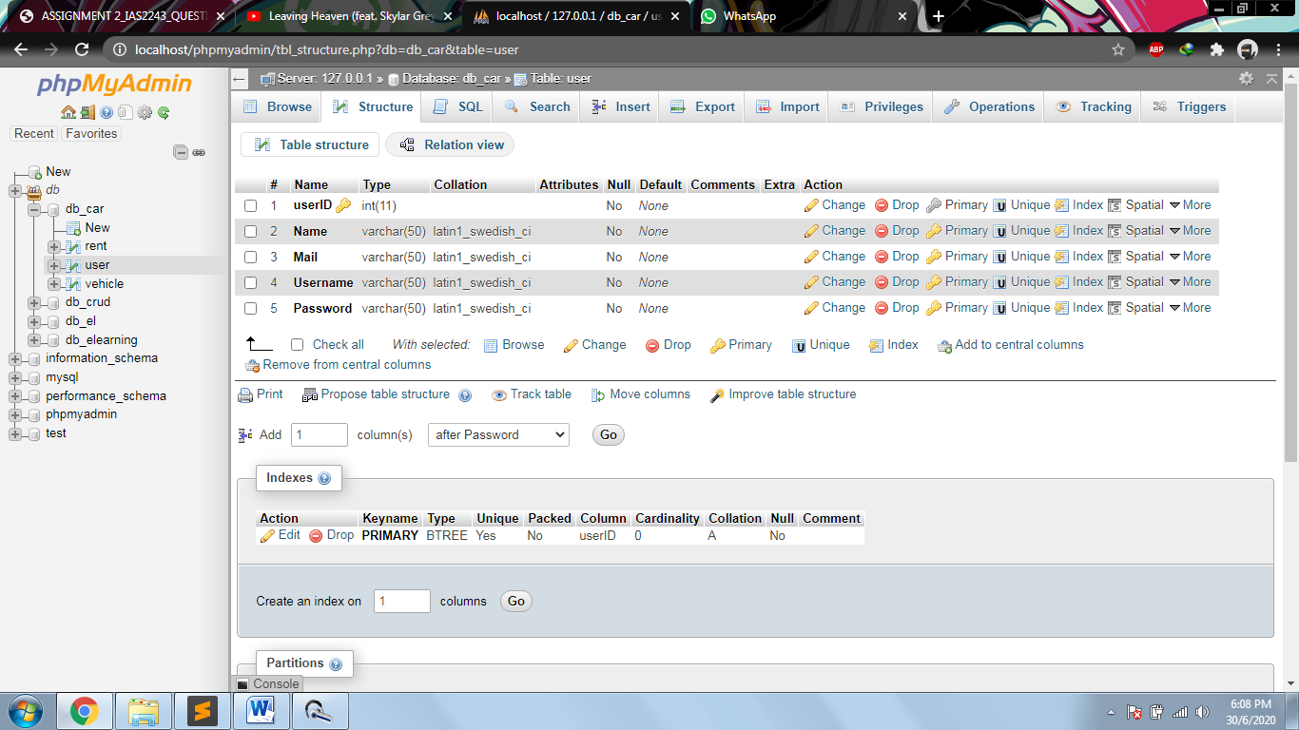

1. Table vehicle

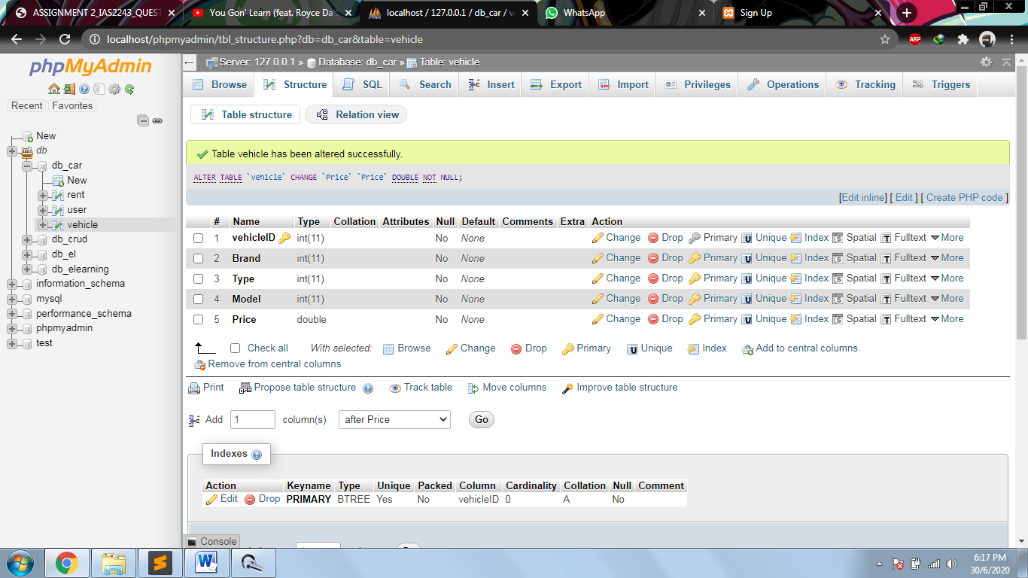

1. Table rent

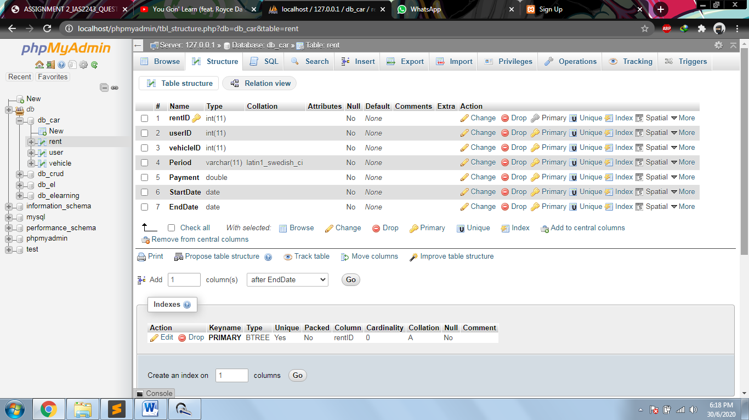

1. Write a coding to link to the Vehicle Rental Management system database which display a message successfully connected to database when the connection is established. Otherwise display Not successfully connected message displayed if the connection is wrongly defined.

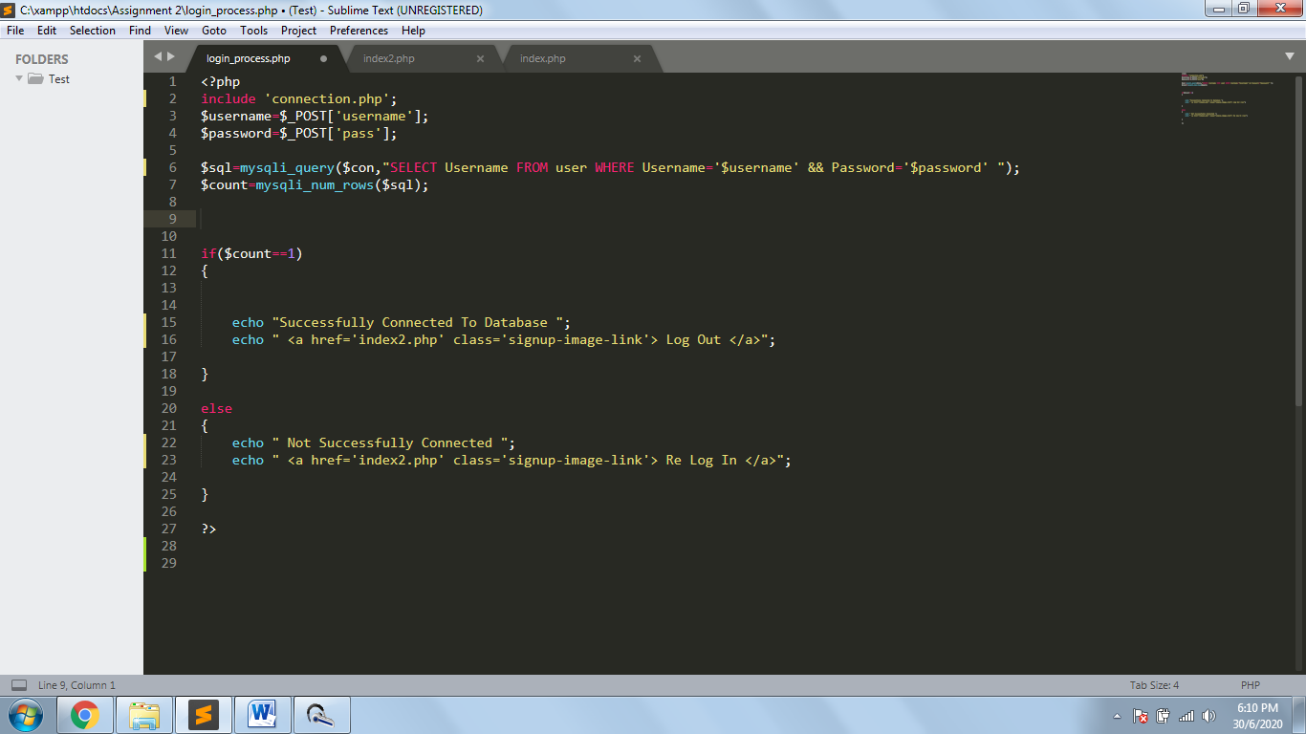

1. Create a login form for the Vehicle Rental Management System (login using email and password). The login credential must be verified from database. You are required to use bootstrap template. Screen shot the created form and output after successful and unsuccessful login.

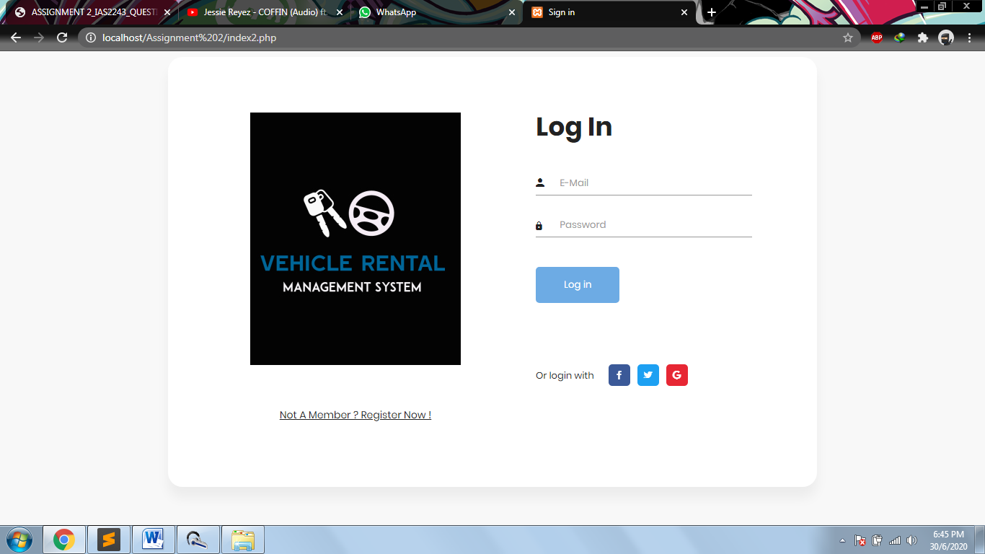

1. Unsuccessful Log In

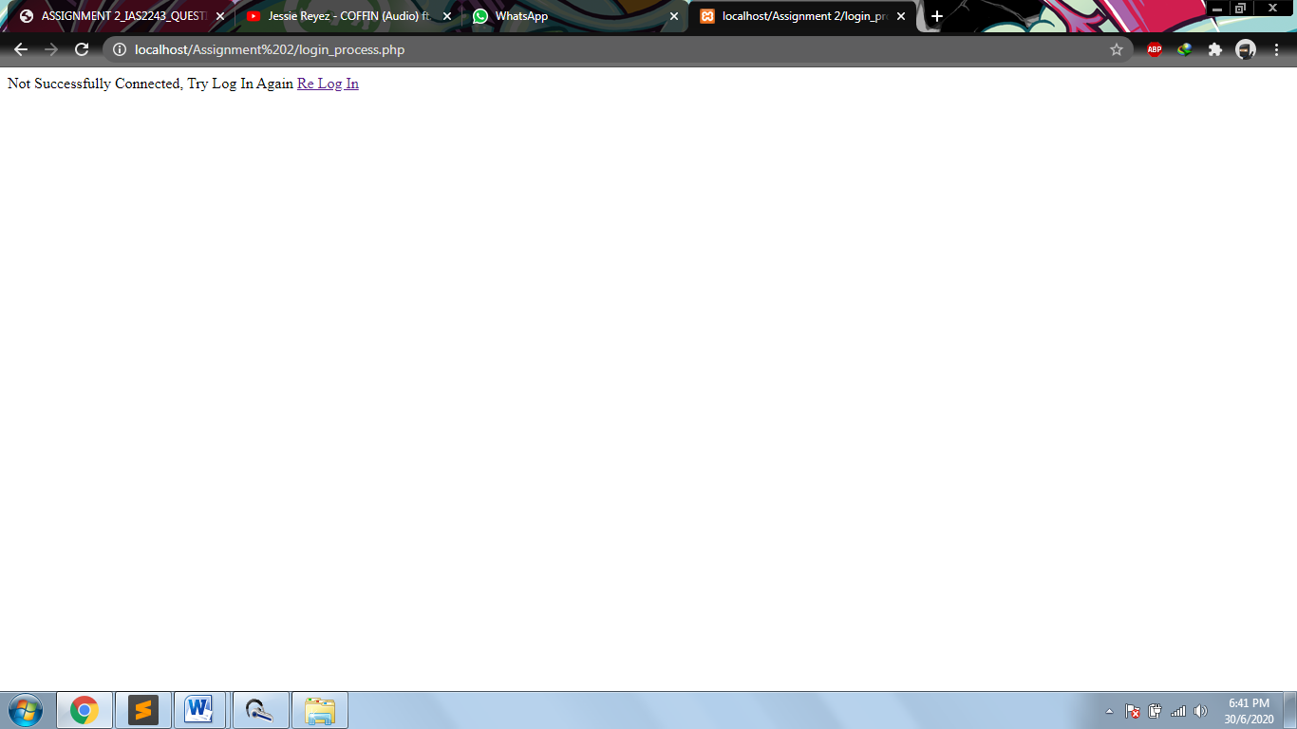

1. Successful Log In

